OTTO CRAB
Abstract:
What can Otto DIY robot do? Otto is an interactive robot that anyone can make!, Otto walks, dances, makes sounds and avoids obstacles. Otto is completely open source, Arduino compatible, 3D printable, and with a social impact mission to create an inclusive environment for all kids.
Requirments:
1 x Nano ATmega328
1 x Nano Shield I/O
1 x cable USB-A to Mini-USB
1 x ultrasound sensor HC-SR04
4 x Micro servo MG90s

Ultrasonic Sensor:

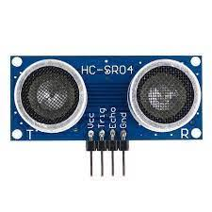
Ultrasonic sensors work by sending out a sound wave at a frequency above the range of human hearing. The transducer of the sensor acts as a microphone to receive and send the ultrasonic sound. Our ultrasonic sensors, like many others, use a single transducer to send a pulse and to receive the echo. The sensor determines the distance to a target by measuring time lapses between the sending and receiving of the ultrasonic pulse. Figure 2 shows the pin configuration for ultrasonic sensor module (HC-SRO4) which includes.
- Vcc (5 volt Supply )
- Trigger pin
- Echo pin
- Gnd (0volt)
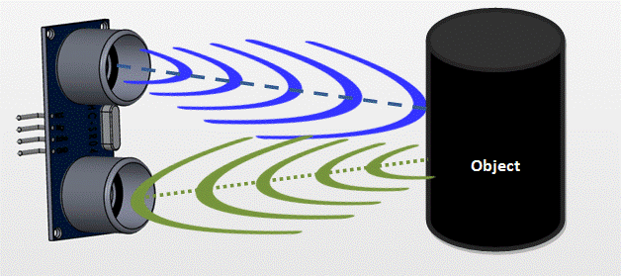
Arduino Nano:
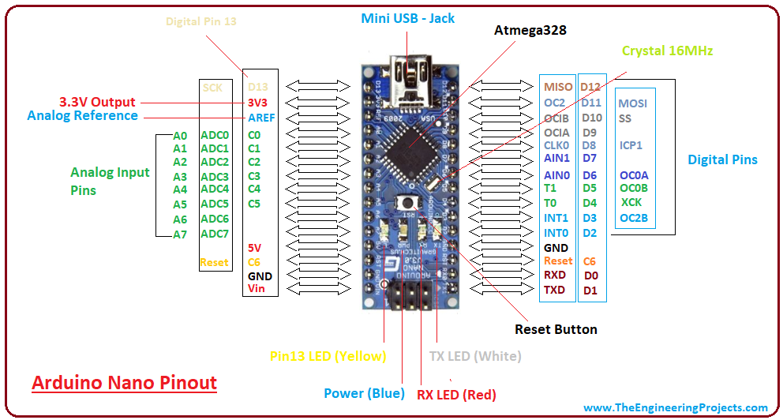
- The Arduino Nano has a compact size and mini USB cable than the Arduino UNO. We can use Nano instead of UNO because both operate on the microcontroller ATmega328p.
- The Arduino UNO is also easily available than Nano. It is considered as the standard board available in the market, which is easy for use for the starters or beginners.
- The Nano is available in PDIP (Plastic Dual - Inline Package), while Arduino UNO is available in TQFP (Plastic Quad Flat Pack).
- The Arduino UNO includes 6 analog pin inputs, 14 digital pins, a USB connector, a power jack, and an ICSP (In-Circuit Serial Programming) header. The Arduino Nano includes an I/O pin set of 14 digital pins and 8 analog pins. It also includes 6 Power pins and 2 Reset pins.

Technical Specifications
The technical specifications of the Arduino Nano board are:
- The operating voltage of the Nano board varies from 5V to 12V.
- The total pins in Nano are 22 Input/Output pins.
- There are 14 digital pins and 8 analog pins.
- There are 6 PWM (Pulse Width Modulation) pins among the 14 digital pins. The 6 PWM pins in Arduino Nano are used to convert the digital signals into the analog signals. The conversion takes place by varying the width of the pulse.
- The crystal oscillator present in Arduino Nano comes with a frequency of 16MHz.
- The Arduino Nano is used in various applications such as Robotics, Control System, Instrumentation, Automations, and Embedded Systems.
- The projects created using Arduino Nano are QR Code Scanner, DIY Arduino Pedometer, etc.
- We can also connect Arduino Nano to the Wifi.
- The functionality of Nano is similar to the Arduino UNO.
- The flexibility and eco-friendly nature of Nano make it a unique choice to create electronic devices and projects with compact size.
Servo Motor:
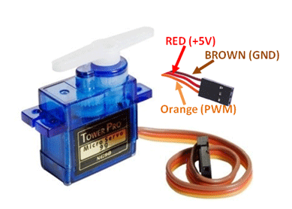

A servo motor is an electrical device which can push or rotate an object with great precision. If you want to rotate an object at some specific angles or distance, then you use servo motor. It is just made up of simple motor which run through servo mechanism. If motor is used is DC powered then it is called DC servo motor, and if it is AC powered motor then it is called AC servo motor. We can get a very high torque servo motor in a small and light weight packages.

Circuit Diagram:
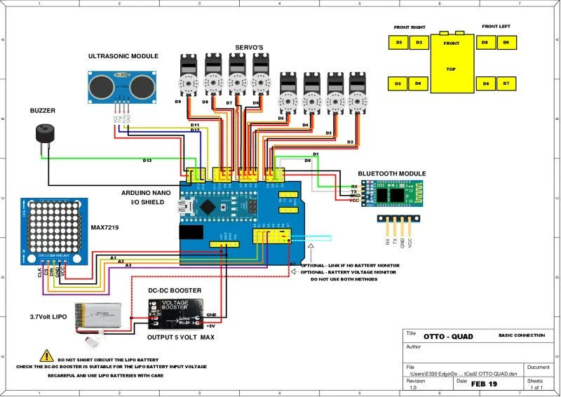

Reference Code:

https://www.printables.com/model/167324-otto-diy-quadruped-robot/files

Conclusion:
They are able to transport payloads between buildings, move parts around factories, and navigate complex, often dangerous construction sites. In all these cases, these four-legged robots are taking on the more repetitive, tiring, and risky aspects of operations to reduce injury and increase efficiency.

